Phase 3: Prepare for the Pilot
3.9 Measurement Plan

Team name

Learning Objectives
- Review behavioral health integration measures currently collected.
- Prepare a measurement plan supporting your Aim statement.
Instructions
- Complete this worksheet outline measure collection plans for your Aim statement

Background:

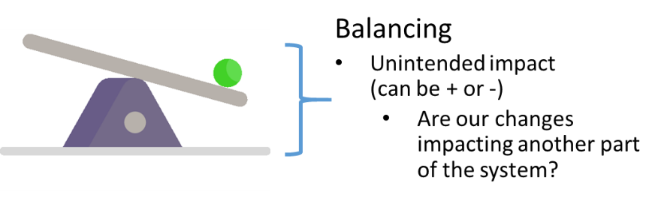

Project name
Aim statement target
How will data be shared with project team (frequency, format, other?)
How will data be shared with frontline stakeholders (frequency, format, other?)

Measure | Measure Type | Description/ Specs | Data Source | Measurement  Frequency | Reporting  Frequency | How will data be presented? | Responsible  Person(s) | Baseline | Target
Include internal ID if using | - Outcome  - Process  - Balance | Include definition of numerator/denominator where appropriate

