The Six Sources of Influence
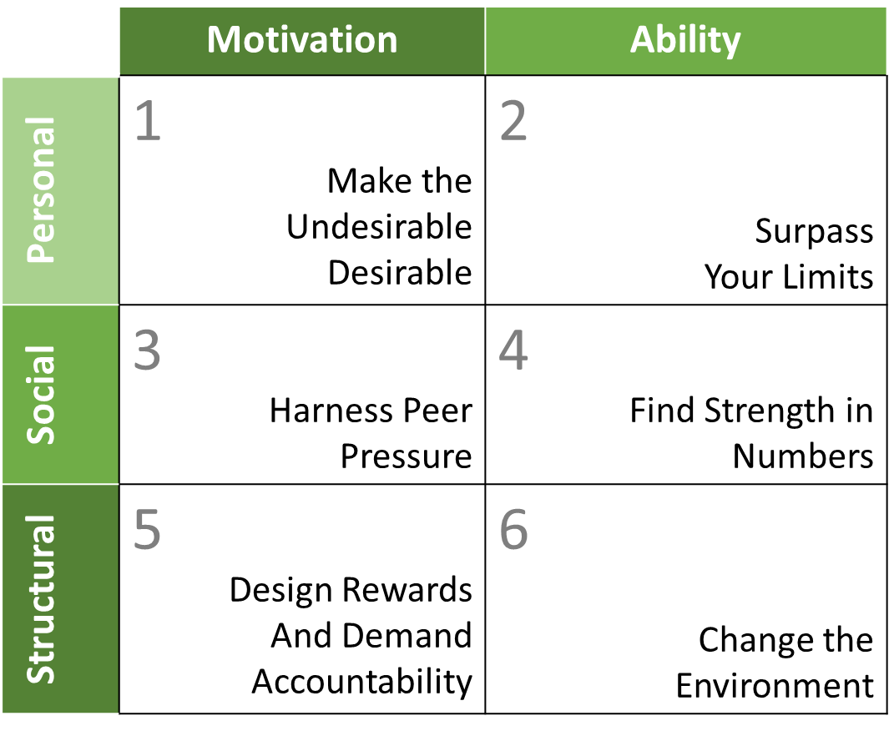

- Personal Motivation (values): Make the undesirable desirable
  - Do they want to engage in the behavior?

- Personal ability (skills): Surpass Your Limits
  - Do they have the knowledge skills, and strengths to do the right thing even when it’s hardest?

- Social Motivation (teamwork): Harvest Peer Pressure
  - Are other people encouraging the right behavior and discouraging the wrong behavior?

- Social Ability (support): Find Strength in Numbers
  - Do others provide the help, information, and resource required at particular times?

- Structural Motivation (incentives): Design Rewards and Demand Accountability
  - Are rewards, pay, promotions, performance reviews, perks, or costs encouraging the right behaviors or discouraging the wrong behaviors?

- Structural Ability (environment): Change the Environment
  - Are there enough cues to stay on course?
  - Does the environment (tools, facilities, information, reports, proximity to others, policies, etc.) enable the right behaviors or discourage wrong behaviors?

Grenny, J., & Patterson, K. (2013). Influencer: the power to change anything. New York: McGraw-Hill Professional.

