Adaptive Leadership Workbook

PTI Annual Convening

February 21, 2018

**Adaptive Leadership Key Concepts & Terms**

# Introduction

We live in a world that is changing at an unprecedented pace. Organizations addressing society's greatest challenges must be able to adapt to changing circumstances if they want to survive and thrive. Yet, adapting to change can be a huge challenge. It usually involves abandoning ways of working that may have once served an important purpose, but are now a liability.

Against this backdrop, the practice of adaptive leadership is about helping organizations confront challenges that they have been unable to face, and increasing the likelihood that people learn, participate in solutions, and make the adjustments necessary to achieve progress (i.e. adapt).

Adaptive leadership is also about enhancing our awareness of other perspectives and recognizing that we operate in the context of a larger system of people who each bring a unique viewpoint based on their experiences, values, family, culture, and beliefs. The adaptive framework provides a set of tools to help us better understand that system and how we can catalyze change within it, without getting sidelined in the process.

# Key Concepts

**Leadership & Authority:** The adaptive framework distinguishes between leadership and authority. Authority refers to one’s role or position. The purpose of authority is to provide protection, direction and order. In the adaptive framework, leadership is viewed as an activity. It is something that you do rather than someone who you are. And because leadership is an activity, anyone can exercise it, whether you are in a position of authority or not.

The conventional notion of leadership emphasizes persuasion and convincing others to follow the pre-defined path of the person in authority. Although such an approach may be necessary at times, there are certain types of challenges for which the person in authority does not actually have the answers (even if s/he may claim to)! In these instances, the work of leadership involves helping people face hard realities and engaging them in solving challenges that have no easy answers.

**Technical Challenges**: Technical challenges are those for which we can find answers through the application of existing knowledge and expertise. We know that by applying a tested solution to a technical challenge, we are likely to get the expected result. Technical challenges can be complex, but are nevertheless solved through solutions that are *tried, tested, and true*. Technical challenges lend themselves to being solved by a person in authority, such as the medical provider who prescribes antibiotics to successfully treat an infection.

**Adaptive Challenges:** In contrast to technical challenges that have known solutions, adaptive challenges do not have easy answers. They require that people gain new knowledge, adopt new practices, or change established behaviors. Adaptive challenges often present as conflicts in values. Because answers to adaptive challenges are neither immediately evident nor solvable by a single person in authority, they must be addressed over time through experimentation rather than a technical fix. Attempts to solve adaptive challenges with technical solutions inevitably end in failure.

**Adaptive Work:** This is the difficult work of shifting values, attitudes and behaviors that is necessary to achieve progress. Adaptive work is about accompanying groups and organizations through the process of learning and loss that comes with change. It involves helping groups adopt new practices that will allow them to succeed in changing environments while letting go of outdated ways of working that hold them back.

**Loss:** In the process of doing adaptive work, groups and organizations are able to maintain some past practices while having to abandon others. Yet, people in organizations have long established patterns of behavior that become hardwired over years, decades, or even centuries! We must recognize that change often involves letting go of established behaviors and that people are likely to react negatively to leaving behind what they hold dear. An important dimension of leadership is accompanying people through those periods of loss while being prepared for the resistance that it is likely to generate.

**Work Avoidance & Giving Back the Work:** Work avoidance refers to the tendency in people to distract themselves or others away from adaptive work by focusing on less important tasks, creating fake work, or deferring responsibility to a person in authority to solve the problem for them. Authority figures often perpetuate work avoidance by being too eager to take up the burden of work for the entire group, usually at their own peril. Such a response may be appropriate in the case of technical challenges when the authority possesses specific knowledge or expertise. However, adaptive challenges do not lend themselves to expertise and technical solutions. They require bringing out the best in the group to solve, and giving back the work where it belongs: to all of us.

**Productive Disequilibrium:** Adaptive work requires engaging people in the process of learning and creative problem solving. Although unsettling, a certain level of discomfort or “disequilibrium” is necessary to help groups grapple with difficult issues and take responsibility for contributing new ideas. The group needs to be vested in the process and pushed towards active engagement in the face of difficult adaptive challenges. If members of the group are disconnected, work avoidant, or “checked out,” the level of disequilibrium is likely to be too low for progress to occur. On the other hand, if the level of stress is overwhelming and conversations are characterized by unproductive conflict or arguments, the level of disequilibrium is likely too high for productive work to get done.

**Regulating the Heat:** Those trying to exercise leadership can intervene in ways that either raise or lower the “heat” to help the group work within a productive range of disequilibrium. If the level of disequilibrium is too low and the group is quiet and disengaged, one might ***orchestrate the conflict*** by raising an important concern or asking a provocative question that gets people re- engaged. Conversely, one might find the tension in the room to be overwhelming and make an intervention to turn down the heat towards a more productive level, for example, by using humor or exercising greater authority. The challenge is not to lower or increase the heat so much that people are no longer engaged in dealing with the real issues.

**Maintaining a Holding Environment:** A holding environment is the “container” that holds people together through the process of doing difficult adaptive work. It can include the properties of the physical space that enable productive conversations to take place as well as group norms and rules of conduct that allow people to feel safe in expressing their views. To maintain a strong holding environment is a balancing act. On one hand, we need to confront work avoidance and challenge people to accept responsibility for solving problems. On the other, we need to keep disequilibrium at a productive level and contain conflict so that it does not get out of hand.

**Diagnosing the System:** One of the great pitfalls of trying to exercise leadership is jumping too quickly to solutions without adequately understanding the problem. Adaptive leadership begins with a diagnosis that is designed to: 1) figure out the actual challenge people are facing; and 2) better understand the system and culture in which we are operating. In diagnosing the system, we try to identify people who have a stake in the challenge, their values, and how those values inform their view of how the work should get done. We also consider the losses and loyalties of stakeholders and the potential factions that can emerge around points of view. By doing a thorough diagnostic, we are better positioned to consider how the system can be mobilized towards adaptive work.

**Running Experiments:** Since adaptive challenges by nature do not have easy answers, they require experimentation in order to learn what works and bring about progress over time. By diagnosing the system, we can formulate an initial working hypothesis about the adaptive challenge and the ways we can learn more or take initial action steps. By running experiments, we can test our assumptions, get back data, learn from our mistakes, and make mid-course corrections (adaptations) as necessary.

**Pacing the Work:** Adaptive work is about helping groups of people grapple with difficult problems and face hard realities. However, in the face of loss and resistance, it is important to pace adaptive work at a rate that people can stand to avoid the risk of being neutralized or assassinated. Those doing adaptive work can make the mistake of proposing too much change, too fast, too soon, and consequently become labeled as the “problem child.” Exercising leadership requires that we work within the stakeholder system to learn, ask questions, test assumptions and introduce new ideas in a careful and thoughtful way.

**The Balcony & Dance Floor:** The dance floor refers to the realm of our daily interactions. When we’re on the dance floor, it is easy to get caught up in the action in ways that obstruct our ability to act thoughtfully and wisely. We only see those who are “dancing” immediately around us. We can also fall into the trap of quickly reacting, making assumptions and personalizing conflicts rather than recognizing that we are part of a larger system of stakeholders with different points of view. Getting on the balcony involves detaching from the immediate situation, looking at the big picture and reflecting on the perspectives of others to better understand where they are coming from. It is also a place where we can design potential interventions or assess whether they had the desired effect. Moving back and forth constantly between reflection, action and adaptation is part of the art of leadership.

**Assassination & Survival:** Those who exercise leadership must be prepared to face its dangers. The loss associated with doing adaptive work can cause people or factions to attempt to neutralize or assassinate (figuratively or even literally) the person whose perspective or ideas they wish to silence. To survive the dangers of leadership, we must remain conscious of the ways that we can be taken out of the game and how our own buttons get pushed, ***holding steady*** (remaining poised and steadfast) in the face of resistance.

***References:***

Heifetz, R.A., Grashow, A., & Linsky, M. (2009). *The practice of adaptive leadership: tools and tactics for changing your organization and the world.* Boston, MA: Harvard Business Press.

Heifetz, R.A., & Linsky, M. (2002). *Leadership on the line: staying alive through the dangers of leading.* Boston, MA: Harvard Business School Press.

Heifetz, R.A. (1994). *Leadership without easy answers.* Cambridge, MA: The Belknap Press of Harvard University Press.

Williams, D. (2015). *Leadership for a fractured world: how to cross boundaries, build bridges and lead change.* Oakland, CA: Berrett-Koehler Publishers, Inc.

Williams, D. (2010). *Orienting concepts for the exercise of leadership (MLD-201B).*

Williams, D. (2005). *Real leadership: helping people and organizations face their toughest challenges.* San Francisco, CA: Berrett-Koehler Publishers, Inc.

**Testing Your Adaptive Challenge**

*Your initial framing of the adaptive challenge is likely to reflect assumptions based on your own experience. The idea behind this exercise is to test those assumptions and learn how your perception of the challenge may be similar or different from the way others view it. Are people sympathetic, or not? What is the level of interest around the problem? Who are your potential allies and who may be resistant? The exercise asks you to engage in conversations with other organizational stakeholders: at least two people who you think will be friendly and two others who may be less so. Complete #1-6 before you begin these conversations and #7-8 afterwards. We encourage you to approach the conversations and questions naturally, in a spirit of curiosity. We also advise that you* ***do not*** *say that you are asking these questions for a leadership program!*

**1. What is the adaptive challenge that you are trying to address in your organization?**

*Use this format: How to [achieve the desired change] against the backdrop of [the countervailing force that is keeping the necessary change from happening].*

**2. How will you test the value and urgency of your adaptive challenge? With whom will you speak?**

**3. Who are the potential allies that may be sympathetic to your cause? Why do you think so?**

**4. Who is likely to be skeptical or resistant to the change you seek? Why?**

**5. Write down three questions you want to ask to frame the conversation.**

**•**

**•**

•

**6. What are your assumptions about these conversations? What do you think will happen?**

**7. What did you notice when you had these conversations? Were your assumptions validated or were you surprised? Did you notice resistance? If you had to do it again, what would you do differently?**

**8. Please re-frame the adaptive challenge in the same format as above based on what you leaned.**

***Diagnostic Stakeholder Map***

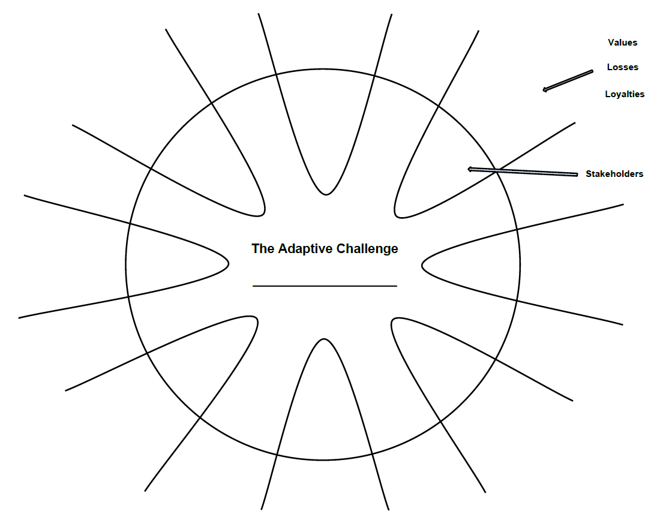



# Adaptive Leadership Intervention Worksheet

**1. What is the adaptive challenge that you are trying to address in your organization?**

*Use this format: How to [achieve the desired change] against the backdrop of [the countervailing force that is keeping the necessary change from happening].*

**2. Intervention Details: What will you do? With whom will you speak or what action will you take?**

**3. What are you trying to learn or achieve through this intervention? What is its purpose?**

**4. What are your assumptions about the intervention? What do you think will happen?**

**5. Results: What was the immediate response to your intervention? What did you notice when you intervened? Were your assumptions validated or were you surprised? Was there any resistance?**

**6. Summarize what you learned from making the intervention. What worked? What didn’t? Did you gain insights into stakeholder values, losses, or loyalties that may impact their ability to address the adaptive challenge?**

**7. What are your thoughts about a next planned experiment based on what you learned?**